Experiment-5

Name: Milan Jani

Enroll No.: 92301733041
AIM: Design FIR filter with windowing method.
Theory:
The windowing method is a commonly used technique for designing FIR filters. It involves designing an ideal frequency response and then applying a window function to obtain a practical FIR filter.

The steps involved in designing an FIR filter using the windowing method are as follows:

Specify the desired filter specifications, such as the cutoff frequency, filter length, and window type.
Design an ideal frequency response that meets the desired specifications.
Apply a window function to the ideal frequency response to obtain the filter coefficients.
Normalize the filter coefficients to ensure stability.
There are various window functions available, such as the rectangular, Bartlett, Hann, Hamming, and Blackman windows, among others. The choice of window function depends on the desired trade-off between the main lobe width and sidelobe suppression.
Program:
import numpy as np
import matplotlib.pyplot as plt
from scipy.signal import firwin, freqz

# Filter parameters
cutoff_frequency = 0.2 # Normalized cutoff frequency (0.0 to 0.5)
filter_length = 31 # Number of filter taps (odd for symmetry)

# Design the FIR filter using Hanning window method
filter_coefficients = firwin(filter_length, cutoff=cutoff_frequency, window='hann')

# Plot the impulse response of the filter
plt.figure(figsize=(10, 5))
plt.subplot(2, 1, 1)
plt.stem(filter_coefficients, use_line_collection=True)
plt.title("Impulse Response")
plt.xlabel("Sample")
plt.ylabel("Amplitude")

# Plot the frequency response of the filter
plt.subplot(2, 1, 2)
frequencies, response = freqz(filter_coefficients)
plt.plot(frequencies, 20 * np.log10(np.abs(response)))
plt.title("Frequency Response")
plt.xlabel("Frequency (Hz)")
plt.ylabel("Magnitude (dB)")
plt.grid(True)

plt.tight_layout()
plt.show()

Output:

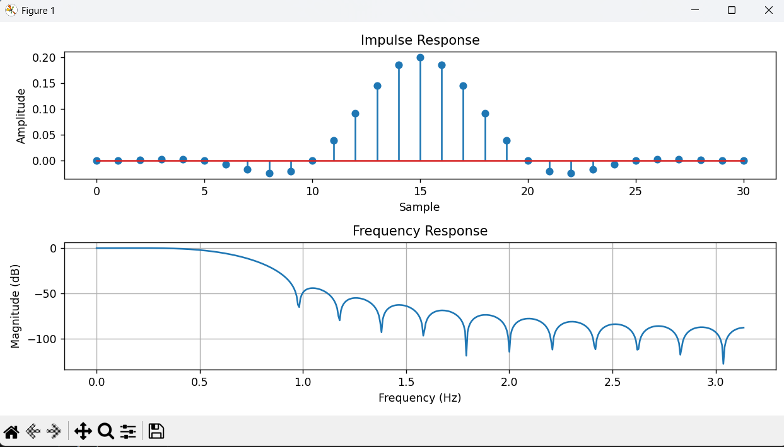

Conclusion:
The FIR low-pass filter designed using the Hanning window method with 31 taps and a normalized cutoff frequency of 0.2 exhibits the expected characteristics of a smooth and well-behaved low-pass filter .The impulse response is symmetric around the center tap, confirming linear phase behaviour, which ensures no phase distortion in the filtered signal. The freq response represents the low pas characteristics , the magnitude is high -40 – 50 db for the hanning window.

